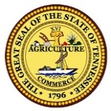 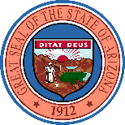 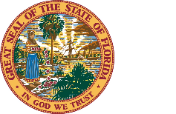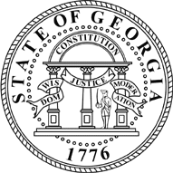 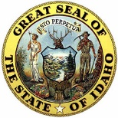

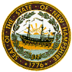 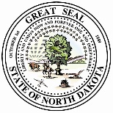

 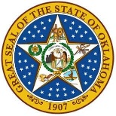 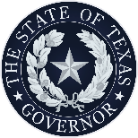 

May 26, 2022

President Joseph R. Biden Jr.

The White House

1600 Pennsylvania Ave NW

Washington, DC 20500

Dear Mr. President,

As governors, we are committed to protecting the life, health, safety, and welfare of our citizens, especially our vulnerable infant population. The supply chain for essential goods is broken, and while we have a vested interest in promoting free commerce amongst our states, a crisis that risks the lives of our youngest demands immediate, decisive, and robust action.

As conditions continue to worsen, we call on you to take action that increases formula availability while also addressing underlying regulatory barriers. Baby formula is essential to 8.2 million Americans who regularly purchase liquid or powdered formula and the estimated 53% of infants aged three months old who receive formula at some point.  After months of inaction, the out-of-stock rate for baby formula now stands at 40% nationwide and up to 50% in six of our states, a crisis exacerbated by surging inflation and the rising cost of consumer goods.

There is perhaps no singular source of nourishment more necessary for the welfare of our nation than the nutrition provided to our infants. In addition to expanding domestic production through your invoking the Defense Production Act, we believe the Administration should identify where regulatory barriers hastened this crisis.

First, we ask that your Administration take more aggressive action to temporarily suspend red tape that limits the importation of safe infant formula from foreign countries.  The U.S. Food & Drug Administration (FDA) claims it will “expedite” the certificate process and “streamline import entry review” and exercise “enforcement discretion” on “minor labeling.”  We agree that importation should be an immediate priority to replenish empty shelves, but until American domestic suppliers are back to full production capacity, your Administration must ensure the rapid importation of foreign formula from trusted trade partners such as the European Union, Canada, Mexico, and others.  Your Administration can take action to end the crisis by:

1. **Immediately suspending all tariffs, quotas, and similar trade restrictions on infant formula until the crisis is abated.** While fair trade negotiations play an important role in protecting our nation’s domestic producers from unfair competition, the current crisis calls for putting consumers and parents first.  We should also incentivize safe, foreign producers to shift product to the United States during this period of scarcity.
2. **Immediately updating FDA labeling standards on foreign formula.**  While the FDA intends to exercise discretion on “minor labeling issues”, now is the time to consider how the federal government can more effectively update the standards to allow import from trusted foreign partners.  For formula originating from countries with equal or higher nutritional requirements, such as many European countries, enforcing labeling restrictions even with discretion limits our ability to resolve the shortage.  Moreover, while there is value in ensuring nutritional labeling is clear for the consumer, this could be achieved by FDA and state agencies partnering to educate the consumer on what newly available products could be substituted for unavailable products.

Longer term, we believe it is important to improve America’s domestic supply chain.  A fragile and tenuous supply chain for essential infant formula puts our economy and families at unnecessary risk.  In addition to taking federal trade and regulatory action, your Administration should consider additional reforms to the U.S. Department of Agriculture Supplemental Nutrition Program for Women, Infants, and Children (WIC) and the FDA recall order process by:

1. **Bringing forward structural changes to the WIC program** to encourage choice and competition in formula and other essential products, including allowing WIC recipients to purchase alternative brands.
2. **Ordering an independent and transparent after-action report of past FDA recall orders**, including recommendations on how the FDA inspection and recall process could be improved and expedited to avoid disruption to critical essential goods and nutrients in the future.

Finally, we must recognize the important partnership with retailers, producers, and non-profits that are going above and beyond to meet the challenge.  We stand ready to enhance the partnership between our states and the federal government as well as the private and public sectors to assist parents in need.  Now is the time parents need the assurance that they can provide the basic necessities for their family, and nothing is more critical than infant formula.

Sincerely,

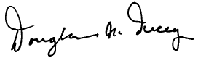

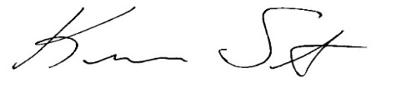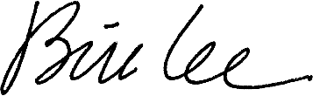

|  |  |  |
| --- | --- | --- |
| Governor Bill Lee  State of Tennessee   | Governor Doug Ducey  C:\Users\lstrickland\AppData\Local\Microsoft\Windows\INetCache\Content.Outlook\2FHJ8137\Brad Little Signature.jpgState of Arizona | Governor Asa Hutchinson  State of Arkansas |
| Governor Ron DeSantis  State of Florida | A picture containing clipart  Description automatically generated  Governor Brian Kemp  State of Georgia | Governor Brad Little  State of Idaho |
| C:\Users\eadams\AppData\Local\Microsoft\Windows\INetCache\Content.Outlook\XRFFG8UO\Gov Kim Reynolds Signature.png  Governor Kim Reynolds  State of Iowa  Text  Description automatically generatedA picture containing hanger  Description automatically generated | C:\Users\eadams\AppData\Local\Microsoft\Windows\INetCache\Content.Outlook\YPN8ZIT9\LarryHoganSignature.jpg  Governor Larry Hogan  State of Maryland | Governor Tate Reeves  State of Mississippi   |
| Governor Greg Gianforte  State of Montana | Governor Pete Ricketts  State of Nebraska | Governor Chris Sununu  State of New Hampshire |
| image1.JPGC:\Users\lstrickland\AppData\Local\Microsoft\Windows\INetCache\Content.Outlook\2FHJ8137\MikeDeWine_blue.png  Governor Doug Burgum  State of North Dakota  cid:0f10bc9f-3c93-4d71-80b5-3f663b81474d@RGA.ORG  Governor Henry McMaster  State of South Carolina  Text  Description automatically generated  Governor Mark Gordon  State of Wyoming | C:\Users\lstrickland\AppData\Local\Microsoft\Windows\INetCache\Content.Outlook\2FHJ8137\Stitt Signature 1.jpg  Governor Mike DeWine  State of Ohio  Shape, arrow  Description automatically generated  Governor Greg Abbott  State of Texas | Governor Kevin Stitt  State of Oklahoma  A picture containing diagram  Description automatically generated  Governor Spencer Cox  State of Utah |